The 2019 New England Library Leadership Symposium will be held August 12th – 16th at the Rolling Ridge Conference & Retreat Center in North Andover, MA. Rolling Ridge is the former estate of industrialist Ethan Allen, and is perched on the banks of Lake Cochichewick.
Rooms and Meals are included in the tuition cost. Students will be placed in dormitory-style rooms. A very limited number of single rooms may be available for participants with a specific or medical need. Vegetarian and Vegan options are available at every meal.
Students and Mentors are expected to reside at Rolling Ridge for the week, which begins on Monday afternoon, and ends on Friday just before lunchtime.
The atmosphere is casual, and canoeing and walking trails are available on the grounds.
For More Information Contact NELLS Co-Chairs:
Mary Etter, Library Director
South Windsor Public Library
So. Windsor, CT
860-644-1541

Krista I. McLeod, Library Director
Nevins Library
Methuen, MA
978-686-4080 ext 10

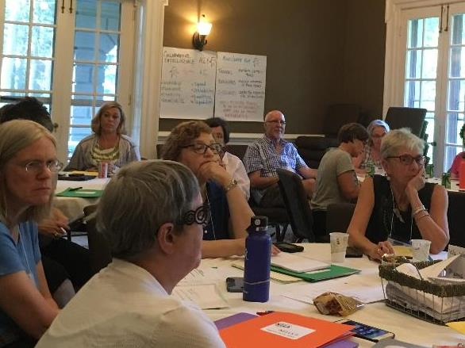

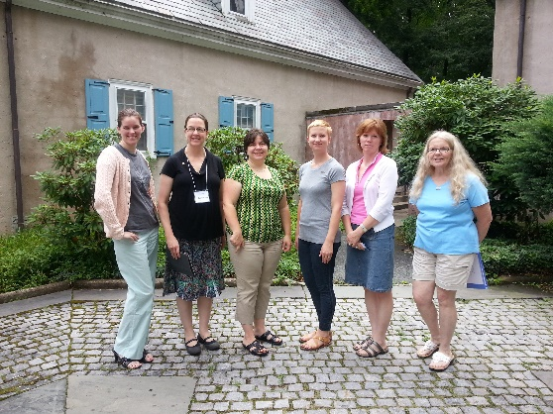

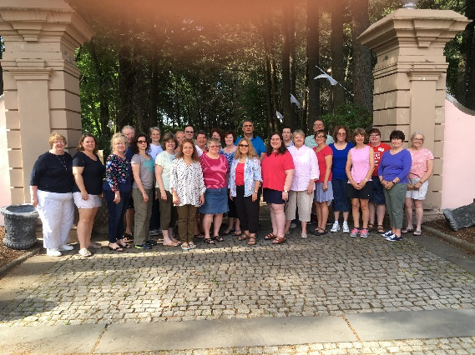

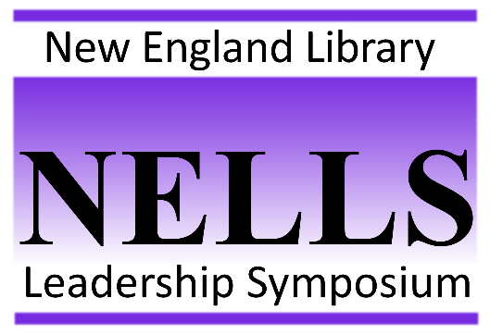
Developing Library Leaders
For New England Since 2003…

NELLS 2019
August 12 – 16, 2019
Rolling Ridge Conference & Retreat Center
North Andover, MA

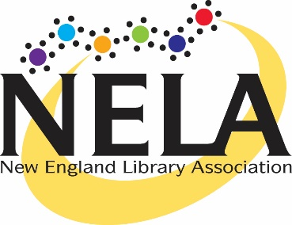

http://nelib.org/connect/committees/new-england-library-leadership-symposium-nells/
What is NELLS?
NELLS is an intensive 4½-day course designed for emerging leaders in all areas of library practice. The purpose of the Symposium is to foster the mentoring and development of tomorrow’s leaders, who are not only pursuing leadership in their communities and institutions, but are also interested in working with library associations, state, regional, and national.

Founded in 2003, NELLS is a program sponsored by the New England Library Association, and supported by the six New England States.
Led by ALA Past-President and Library Consultant Maureen Sullivan, and guided by experienced librarian-mentors from around New England, NELLS Participants follow an established curriculum, using real experience, up-to-date research on leadership, and discussion and reflection to bring out individual leadership qualities.
NELLS is held every other summer, in odd-numbered years. Participants must have less than 15 years’ experience in libraries.
NELLS is partially supported by contributions from the New England states, which helps keep tuition lower for Participants. 2019 Participant tuition will be announced; but as a guideline Participants should plan on approximately $600. Scholarships may be available from State Associations.
What is NELLS II? NELLS II is a 3-day Retreat for experienced library leaders. The purpose of this Retreat is to refresh and renew library practitioners and to hone Participants’ skills as senior library leaders in their communities, states and beyond. Each NELLS II focuses on a current topic of interest to library staff, but also brings new research and methods to the discussions of current problems and issues.
Established as an outgrowth of the NELLS program in 2016, NELLS II is designed for library practitioners with more than 15 years’ experience in libraries. Led by renowned Library Consultant Maureen Sullivan, this program is held every other summer, in even-numbered years.
NELLS II is a self-supporting program, and the cost of tuition includes materials, room and board at Rolling Ridge Conference & Retreat Center. The tuition fee for 2020 is not set yet, but in 2018, total cost for each Participant was $800.
Upcoming Dates
NELLS August 12-16, 2019
NELLS II Summer 2020
NELLS Summer 2021
NELLS II Summer 2022
Applying for NELLS 2019
Applications for NELLS 2019 will be available on the NELA web site beginning on December 1, 2018. Applications, along with 3 letters of recommendation must be completed by March 15th, 2019.

NELLS is highly competitive, and selections will be made by a panel of experienced library leaders. Prospective participants are encouraged to apply, and if not selected in the first year, to consider re-application.
A demonstrated interest in professional involvement in library associations and organizations beyond one’s employment is favorably considered by the selection committee.

Who Can Attend in 2019?
Library professionals, paraprofessionals, and volunteers (trustees, friends) in mid-career (3-15 years’ experience in or with libraries) are eligible to participate in NELLS. Those with more than 15 years’ experience are urged to apply for NELLS II in 2020. All candidates are required to be members of their state association or NELA in order to apply. No more than 28 students will be selected to participate in the 2019 program.

2019 Costs
Participant tuition in 2019 will be $700, including room & board. Applicants are urged to check into scholarships which may be offered by their state association.

